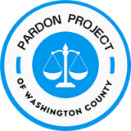
B
PARDONS in PENNSYLVANIA

Did You Know?
The Pennsylvania pardon process is free and does not require a lawyer.

A pardon is a powerful tool for people who deserve a second chance. A pardon erases your record like it never existed so that you will never have to “check the box” again. Pardons allow people to get better jobs, education, housing, and opportunities which help them, their families, and their communities.

Though there are no hard-and-fast rules for who gets a pardon, from having watched hundreds of votes, successful pardon applicants:
- have fully completed their sentence (not on probation or parole)
- have not been arrested in the past 5 years (10 years if any crime involved sex or violence more significant than simple assault)
- can show they’ve turner their lives around – through letters of recommendation, certificates, diplomas, success at work, etc.
- have done things to help others

80% of people who get a hearing before the PA Board of Pardons actually end up with a pardon!
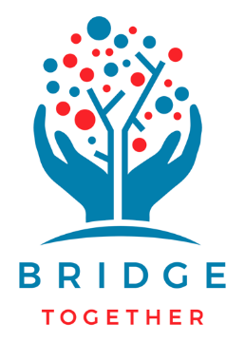
Need Help or Want More Information?
Pardon Project of Washington County
www.spla.org/pardon
email us: PardonMe@splas.org

And be sure to register to vote, because
YOU CAN VOTE in PA!
www.vote.pa.gov

Not everyone will be eligible for a pardon or for free legal help in applying.

